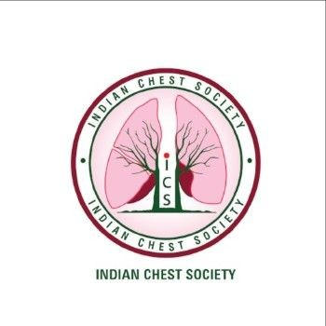
INDIAN CHEST SOCIETY

APPLICATION FORMAT FOR ORATION AWARD

(Format can be downloaded at the ICS website. Application should be prepared with MS word.
Five printed signed copy to be mailed to Secretary Office/Treasurer Office)

Name of the Applicant: ……………………………………………………………………………….……
Membership No.:………………………..……... Date of Birth: …………………………Sex:……....……
Communication Address: ………………………………………………………………………….………..
District:….…………………………… Postal Code: …..…. State: …………...……….Country…..……..
Mobile Number: ………………………………………… Email: ………………………………………….
1. Educational Qualifications:
Medical Qualification | University/Institution | Qualifying Year

2. Teaching and/or Professional Experience to date
Sr. No | Designation | Hospital | Period

4. Awards of Professional Recognition (Specify the name(s) of the Award(s) with year

5. Representation in International / National Organizations / Committees / Bodies / Institutions

6. Role in ICS/International Respiratory Societies with year(s) of serving

7. Any Other Information

8. Verification
I the undersigned hereby affirm and declare that the information given above is true to the best of my knowledge and nothing has been concealed or overstated there-in. I further declare that I have never been indicted in professional/academic misconduct and no such complaints or proceedings are pending against me.

Date:
(Signature of the applicant)

